# Computer Graphics

Project Name: Rocket with Airstrike Game

Requirement Collection:

* Main Menu
* Difficulty levels
* Score display
* Identifying the game with some features like moving rocket , collision detection , planes , bombs , scoring difficulty
* Score display using file read to show the display

Requirement Analysis:

* User: Me or My friends
* User to start this game using option choose and its user friendly
* Choose difficulty level and play the game like conditions

Requirement Validation:

* Checking all the game rules and other things are implemented correctly
* Ensuring the game works through debugging and testing

Module Identification:

* Divide the game with different modules like Plane , Rocket , BigPlane , Boom , BigPlane Bomb .
* Separating concerns such as rendering , event handling and logic

**Scenario diagram:**

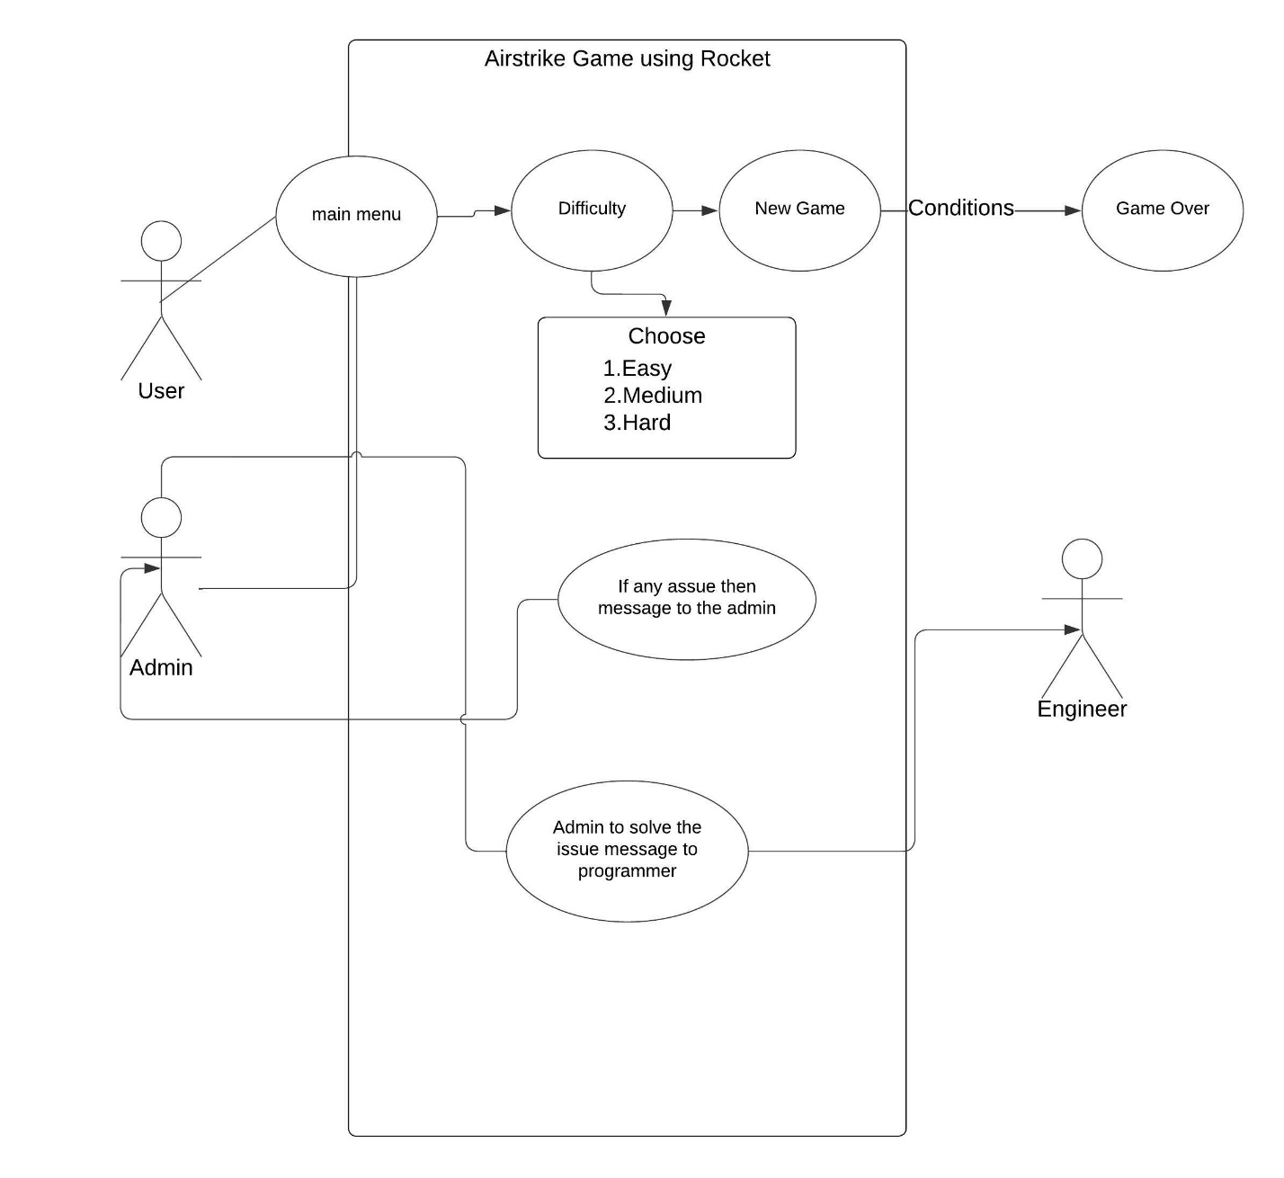

**UI Interface Design:**

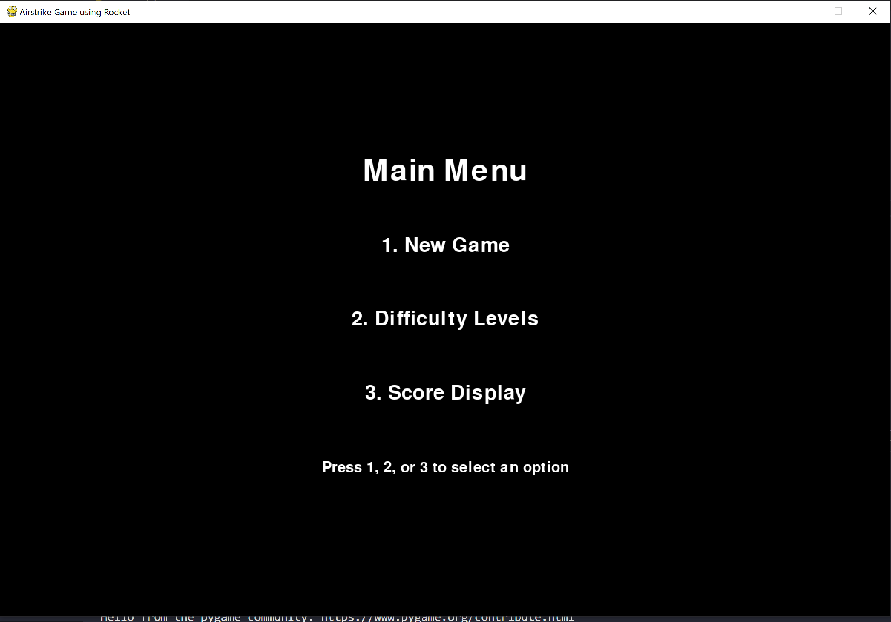

**Class Diagram:**

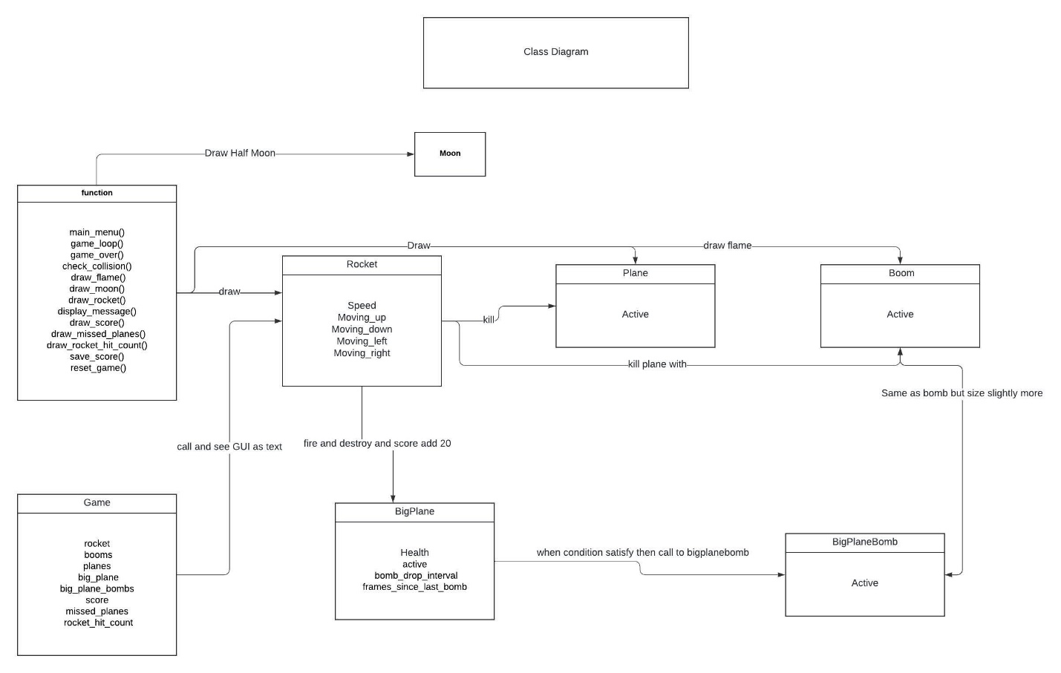

**Software Testing:**

* Testing different features of the game like collision detection, movement, score updating, and game over conditions.
* Manual testing through gameplay and ensuring all features work correctly.

**Estimation for software Project:**

* I use the bottom up estimation technique because of detailed planning , more accuracy , easier justify to transparency , potential granular level at risk management.

**Sequence Diagram:**

Player -> Rocket: pressSpacebar()

Rocket -> Game: createBoom()

Game -> Boom: Boom()

Loop (for each frame)

Game -> Boom: move()

Boom -> Plane: checkCollision()

alt if collision

Boom -> Plane: deactivate()

Boom -> Game: incrementScore()

end

end

**Computer Graphics term used:**

* **Rendering**: Drawing shapes and rendering text
* **Transformations**: Moving Object and Scaling
* **Collision Detection**: for Objects
* **Animation**: moving objects and create flame effects
* **Event Handling for user input**
* **Sound integration**